CLDV6212

Part 2

**Azure Event Hubs**

**Description of Service**

Azure Event Hubs is a cloud-based service designed to manage high-throughput data streams. This service is used as an event ingestion service and big data streaming platform which enables real-time analytics on large amounts of data from various sources. This service is capable of handling millions of events per second, which provides an easy way to capture, process, and analyse event data. (anon, 2024)

**Mechanism**

* **Event Ingestion**: Azure Event Hubs allows the ingestion of data from multiple data sources such as IoT devices, applications, and websites.(anon, nd)
* **Partitioning**: Event hub events are stored in partitions which allows for parallel processing of data therefore ensuring high throughput, meaning that the multiple consumers can access the same event hub simultaneously.(Das, 2022)
* **Integration**: Event hubs can be integrated with different other azure functions for real-time data processing and analysis.(Das, 2022)

**How It Adds Value to End Users**

1. **Real-Time Data Processing**: Event Hubs gives organisations the ability to react instantly to client behaviours and preferences by offering real-time analytics. When a consumer engages with a product, for instance, the system may instantly evaluate the information to provide recommendations that are tailored to them.(alam, 2023)
2. **Scalability**: Event Hubs guarantees that client data is always collected and processed, regardless of the amount, with the capacity to handle millions of events per second. This keeps everything running smoothly and avoids data loss during busy periods.(alam, 2023)
3. **Enhanced Insights**: Event Hubs help organisations make better decisions and increase customer satisfaction by gathering data on customer interactions and behaviours. This data may be used to identify consumer preferences and trends.(alam, 2023)

**Azure Event Bus**

**Description of Service**

Azure Event Bus, which is sometimes used interchangeably with Azure Service Bus, is a messaging service designed to let applications and services communicate with one other. It ensures message delivery even in intricate systems by enabling applications to transmit messages across various components in a dependable and decoupled way.(anon, 2023)

**Mechanism**

* **Message Queues and Topics**: Message queues for point-to-point communication and topics for publish-subscribe scenarios are supported by Service Bus. As a result, communications can be handled asynchronously, increasing system dependability and performance.(anon, 2024)
* **Dead Letter Queues**: Unsent messages are sent to a dead letter queue ensuring that messages aren’t lost.(anon, 2024)
* **Integration**: Azure Service Bus can easily integrate with various Azure services.(anon, 2024)

**How It Adds Value to End Users**

1. **Reliability**: Azure Bus ensures that messages are delivered reliably and in order which enhances consistency and reliability.(Dynamics, nd)
2. **Decoupled Architecture**: Event Bus provides more flexibility and scalability by allowing services to communicate without being tightly linked. This implies that the user experience won't be hampered when specific components are upgraded or scaled independently.(anon, nd)
3. **Enhanced Responsiveness**: With asynchronous message processing, users can receive faster replies from the application by handling many requests at once. Processing alerts or payment transactions, for instance, can be done effectively without preventing user activity.(Dynamics, nd)

Bibliography

Alam, I. (2023) *Azure event hub: Event hub architecture: Working*, *Cloud Training Program*. Available at: https://k21academy.com/microsoft-azure/data-engineer/azure-event-hubs/ (Accessed: 01 October 2024).

*Azure event hubs and its complete overview* (2024) *Turbo360*. Available at: https://turbo360.com/guide/azure-event-hub (Accessed: 01 October 2024).

*Azure EventGrid & Service Bus: Scalable Event Architectures* (2024) *Multishoring*. Available at: https://multishoring.com/blog/building-scalable-event-driven-architectures-with-azure-event-grid-and-service-bus/#:~:text=In%20Azure%20Service%20Bus%2C%20it’s,react%20to%20the%20same%20event. (Accessed: 01 October 2024).

*Azure service bus vs azure event hub: A technical guide* (2023) *softwebsolutions*. Available at: https://www.softwebsolutions.com/resources/azure-service-bus-vs-event-hub.html (Accessed: 01 October 2024).

Das, D. (2022) *Azure event hub*, *ThirdEye Data*. Available at: https://thirdeyedata.ai/azure-event-hub/#:~:text=Event%20Hubs%20provides%20message%20streaming,unavailable%20in%20queues%20and%20topics. (Accessed: 01 October 2024).

Dynamics, I. (no date) *Azure service bus use cases and benefits: Microsoft partner*, *Imperium Dynamics*. Available at: https://imperiumdynamics.com/azure-service-bus-usecases-&-benefits#:~:text=It%20allows%20for%20efficient%20message,%2C%20duplicate%20detection%2C%20and%20partitioning. (Accessed: 01 October 2024).

*Microsoft Azure Event Hubs* (no date) *element61*. Available at: https://www.element61.be/en/competence/microsoft-azure-event-hubs (Accessed: 01 October 2024).

Screenshots

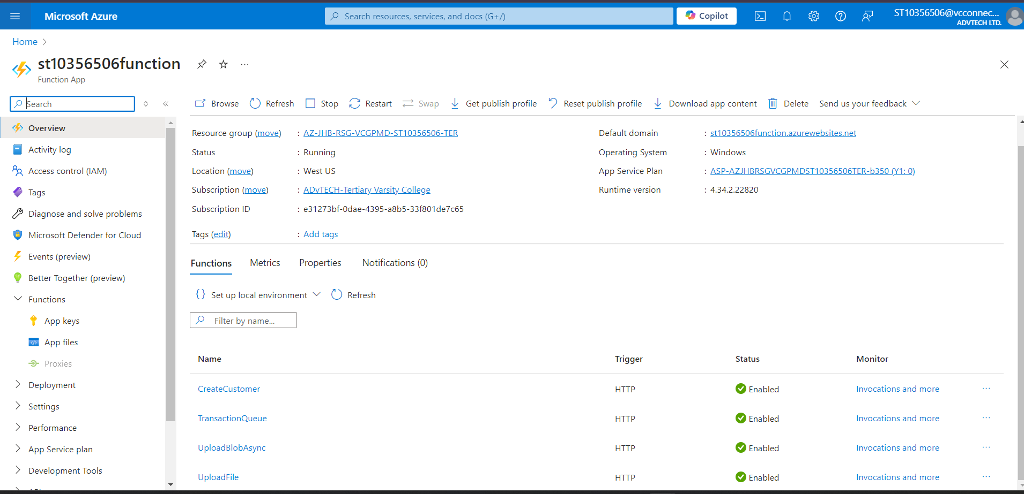

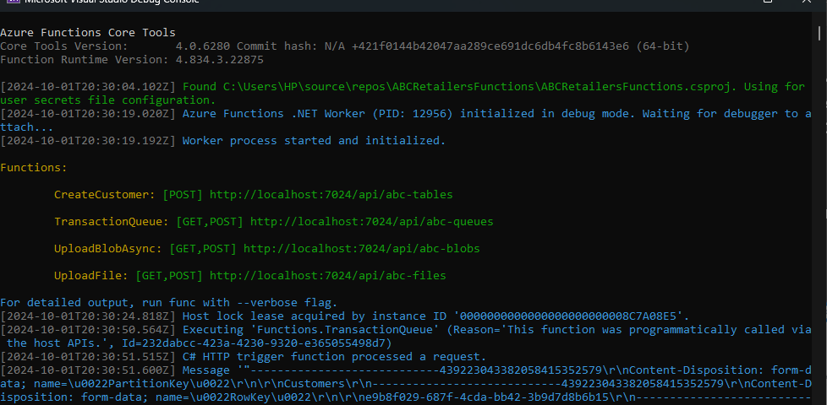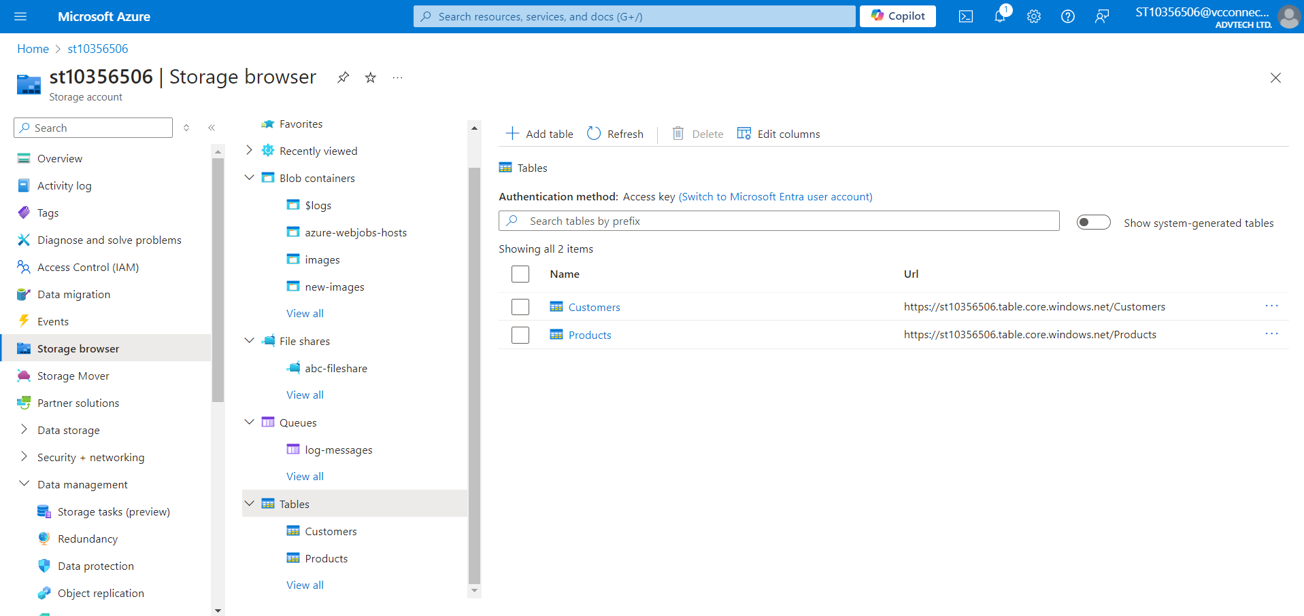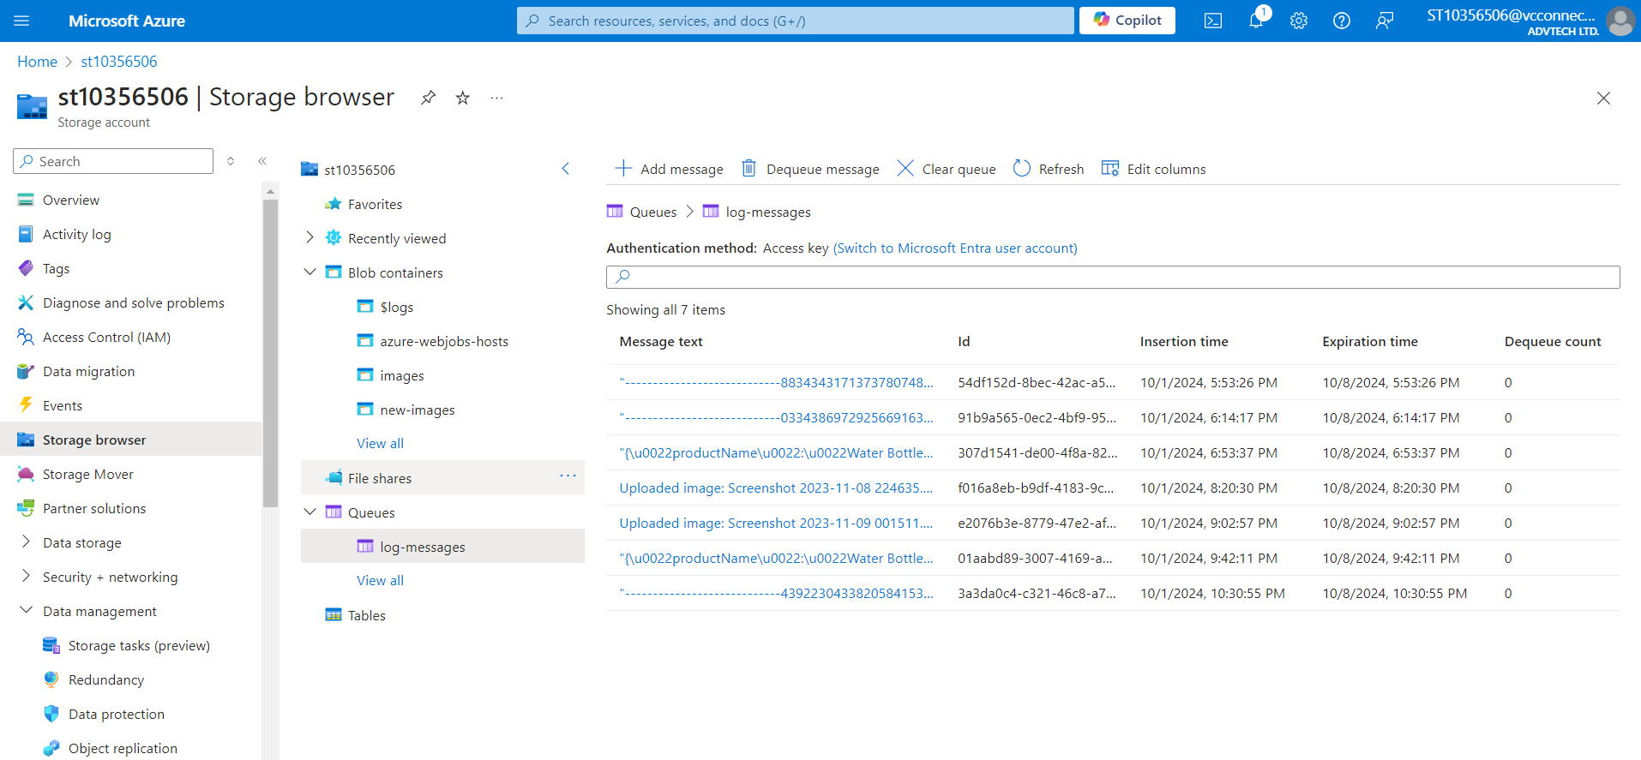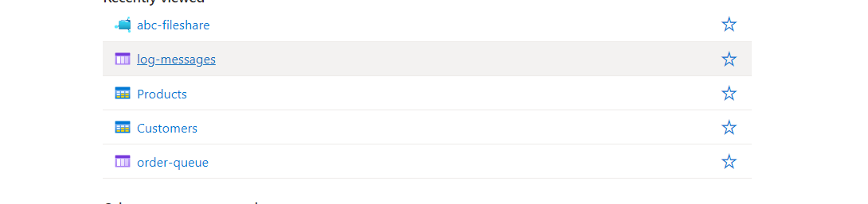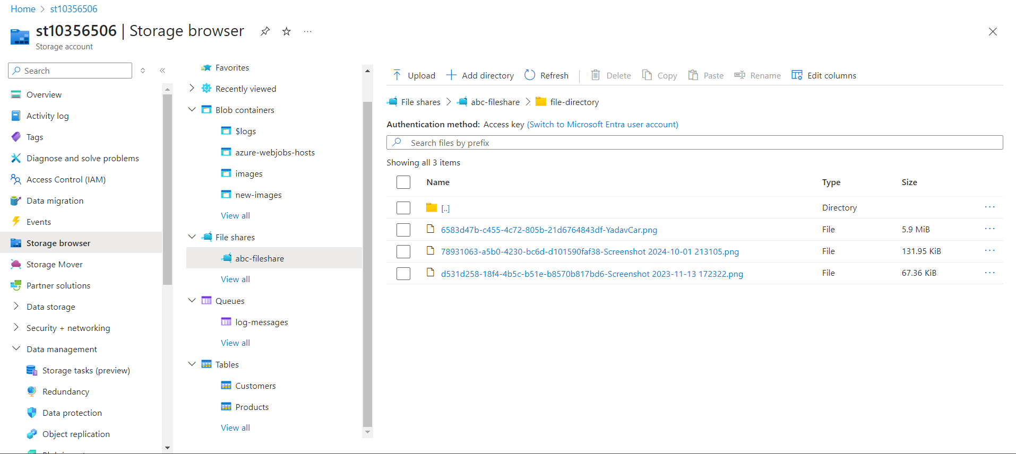

I linked my azure function app and web app, and everything worked perfectly locally, local URLs all hit their endpoints on postman. When I published my projects, they did not work anymore. I tested the deployed links in postman and they worked too.

URL’s

Web app: <https://st10356506abc-c5haavbjg7eyeqcx.brazilsouth-01.azurewebsites.net>

Function app: <https://st10356506function.azurewebsites.net>

Github link: